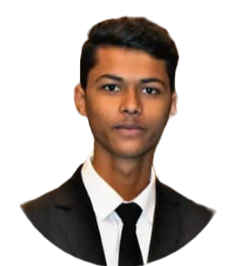

V

**Hemant Patil**

[Ph70995@gmail.com](mailto:Ph70995@gmail.com)

+91 7028665121

Shirpur , Maharashtra

Age - 23

**Customer Service Associate (International Destination )**

**Bachelor’s In Airlines, Tourism and Hospitality**

Lovely Professional University | Phagwara , INDIA

CGPA 7.09 (Aug 2019 – 2022)

**Higher Secondary**

R.C.Patel Jr. College , Shirpur

CGPA 6.6 June (2018 – March 2019)

**Education**

* Bootcamp in entrepreneurship
* Psychology of happiness

**Open Elective Course**

* + Ensured customer satisfaction and loyalty.
  + Provided timely and accurate solutions.
  + Maintaining positive customer relationships.
  + Identify and address customer pain points.
  + Meet or exceed customer service metrics (e.g., response time, resolution rate).

**Thrillophilia** (May 2022 – 2023)

* Salesforce | PipeDrive
* Excel
* Powerpoint
* Word
* Business Development Strategy
* Team Managment

**Summary**

Resolves product or service problems by investigating the customer's complaint, determining the cause of the problem, selecting and explaining the best solution for the problem, expediting correction or adjustment, and following up to ensure resolution and customer satisfaction.

**Experience**

* Marathi
* Hindi
* English

**Languages**

* Attended an international conference where Tourism professionals gatheredand discussed Sustainable Tourism Development
* Attended the mocktail workshop

where industry professionals

came and showed how to make

different kinds of mocktails.

**Extra Curricular Activities**

* 1 Year at Thrillophilia ( Customer Service Associate)
* Completed Online course on Affiliate Marketing & Social Media Marketing
* Completed Ministry of Tourism approved Tourism Expert certification of Spanish and Southwest German Tourism

**Certification**

**Skills**

* Worked as Student Coordinator at LPU in World Tourism Day 2019 and Spectra 2019
* Elected and acted as School Head Boy, was constantly alert, observant, and sensitive to the needs of the school and students and acted promptly after consulting and getting orders from the Principal

**Achievements**